

**Software Engineer for Cloud Project 1**

|  |  |
| --- | --- |
| **Instructions** |  |
| Every screenshot requested in this workbook is compulsory and carries 5 marks. Updated Python Script carries 20 marks. Lambda Function Code In Python carries 25 marks. | |
| Your AWS account ID must be clearly visible in every screenshot using the AWS console; missing id or using someone else's id is not permitted. Such cases will be considered as plagiarism and severe  penalty will be imposed. | |
| All screenshots must be in the order mentioned under "Expected Screenshots" for every step | |
| DO NOT WAIT UNTIL THE LAST MINUTE. The program office will not extend the project submission deadline under any circumstances. | |
| The file should be renamed in the format BATCH_FIRSTNAME_LASTNAME_PROJECT1. For example: | |

|  |  |
| --- | --- |
| **Resource Clean Up** |  |
| Cloud is always pay per use model and all resources/services that we consume are chargeable.  Cleaning up when you’ve completed your lab or project is always necessary. This is true whether you’re doing a lab or implementing a project at your workplace. | |
| After completing the lab, make sure to delete each resource created in reverse chronological order. | |

**Submission Files -**

You need to submit the following -

1. Project workbook with added screenshots.

2. Updated Python script (StockPriceIngestion.py)

3. Lambda Function Code In Python

**Problem Statement :**

We want to build a system that streams stock pricing information for various stocks and then notifies the stakeholders about the fetched information of the stocks.

We’ll use the Yahoo Finance APIs to query the running price of stocks and general information like 52-week high/low values.

This file is meant for personal use by snbaskar@gmail.com only.

Sharing or publishing the contents in part or full is liable for legal action.



**Yahoo Finance API** - It provides functions to download historical market data from Yahoo! finance. While this functionality in production would generally run on a paid api that provides real-time stock price data, we’ll mimic it by using historical data for an older time period and streaming it over kinesis.

**Link** - https://pypi.org/project/yfinance/

Please go through this link to understand how to access different stocks data and information. You need to pull the data for the following 10 stocks -

MSFT, MVIS, GOOG, SPOT, INO, OCGN, ABML, RLLCF, JNJ, PSFE

You can check the details of these stocks here - https://finance.yahoo.com/lookup/

**Architecture diagram**

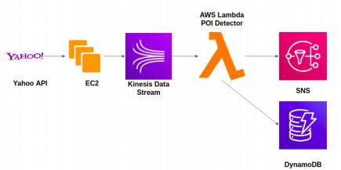

|  |  |
| --- | --- |
| **Architecture Implementation** | |
| 1 | Create EC2 Instance |
| 2 | Run Python Script to Pull data from Yahoo Stock API |
| 3 | Use boto3 and kinesis client to Push data from EC2 to Kinesis Stream |
| 4 | Configure SNS to publish the notification through mail, Configure DynamoDB to store the alert data. |
| 5 | Write a Lambda function to detect the POIs and to Push the Notification to SNS |
| 6 | Use the same Lambda Function to push data to DynamoDB |

Step 1: Create EC2 Instance

This file is meant for personal use by snbaskar@gmail.com only.

Sharing or publishing the contents in part or full is liable for legal action.



|  |  |
| --- | --- |
| Step number Step name Instructions  Expected  screenshots | a  Create EC2 Instance  1) Navigate to EC2 Services from AWS management console page  2) Choose `instances` available in the left pane.  3) Click on `launch instances`  4) Choose the free tier for `Amazon Linux`  5) Choose instance type as t2.micro  6) Configure instance details keep all the option as be default  7) Keep default storage option and provide optional tag details  8) Create a new security group for the instance.(Configure SSH option) Make it more secure by choosing source as MyIP.  9) Click on the launch button, It will prompt you to create a new key pair. Provide the name and download the key for login purposes.  1) Created EC2 instance running on the instances page. |

**<Insert Screenshot a(1) here>**

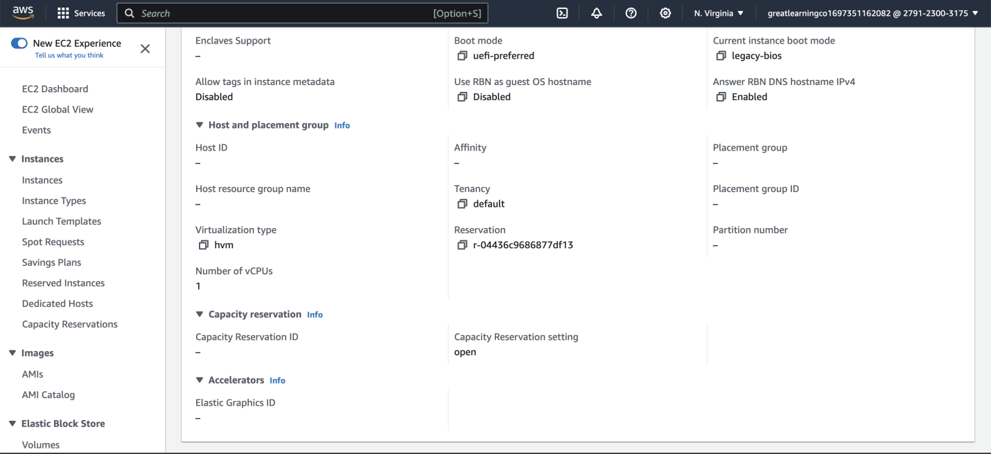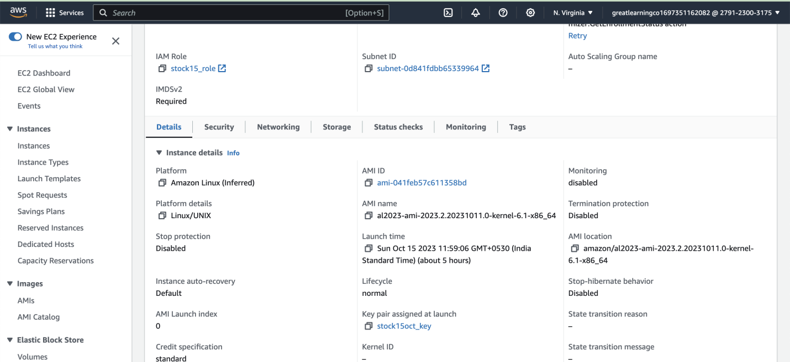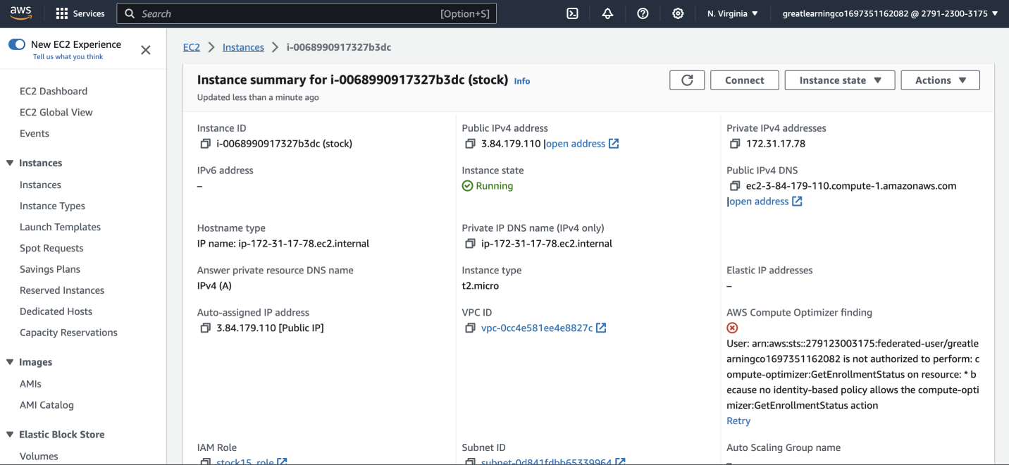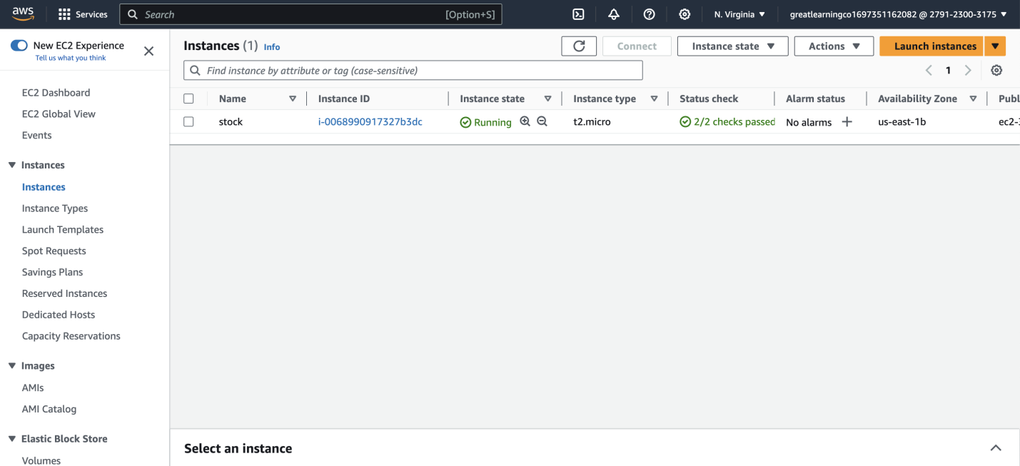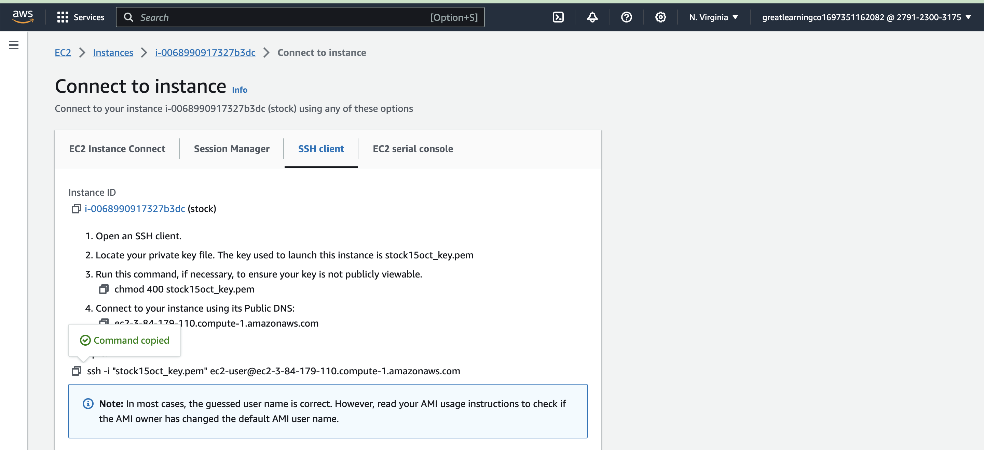

|  |  |
| --- | --- |
| Step number  Step name  Instructions | b  Use SSH to login into EC2 instance  1) Depending on the operating system you are using do the SSH login on the EC2 instance  2) For windows system use puttygen to convert the pem file into ppk and then do the login using putty  3) For linux based system perform the normal SSH  guideline available on AWS instance→ connect page |
| Expected  screenshots | 1) Logged in screenshot of the newly created instance |

**<Insert Screenshot b(1) here>**



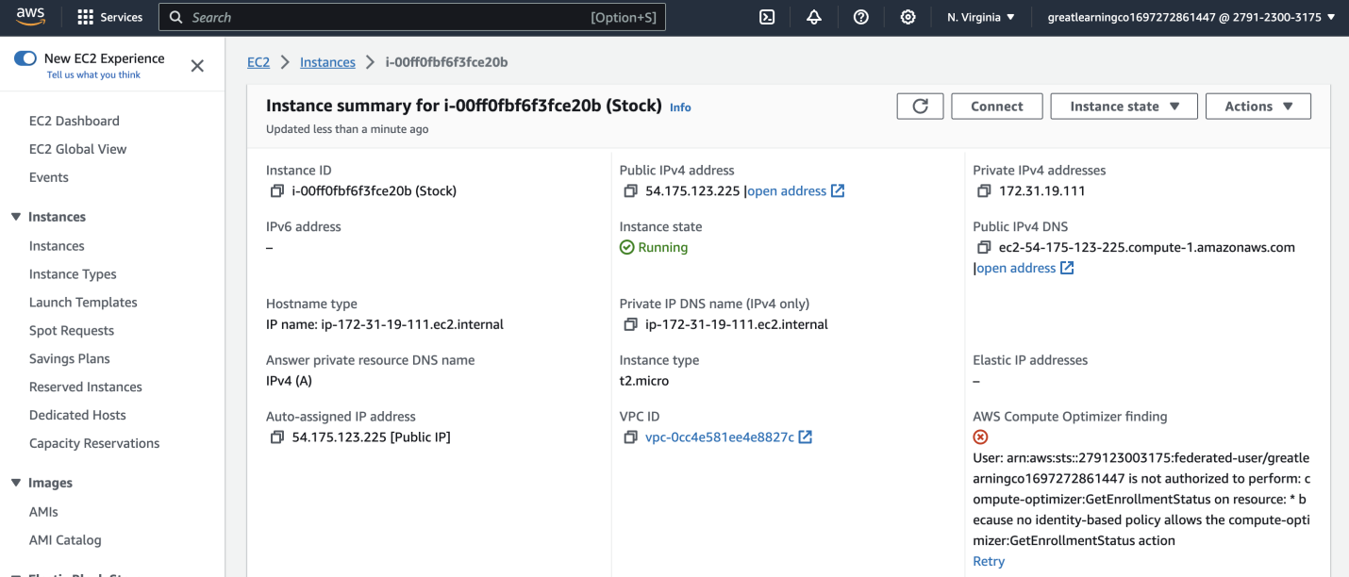

This file is meant for personal use by snbaskar@gmail.com only.

Sharing or publishing the contents in part or full is liable for legal action.

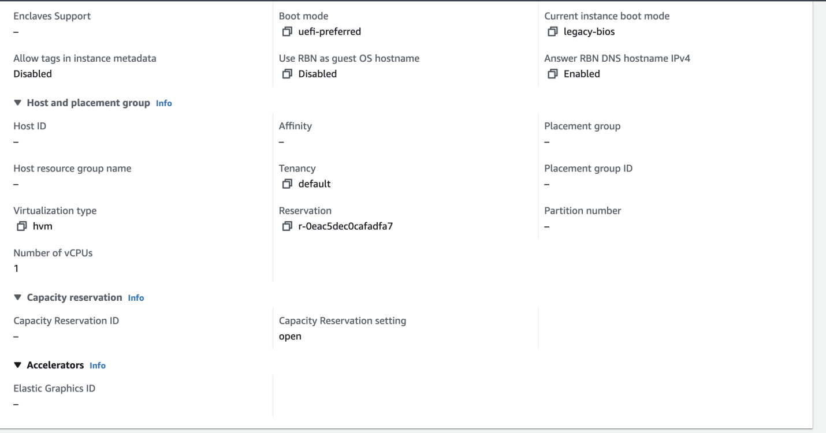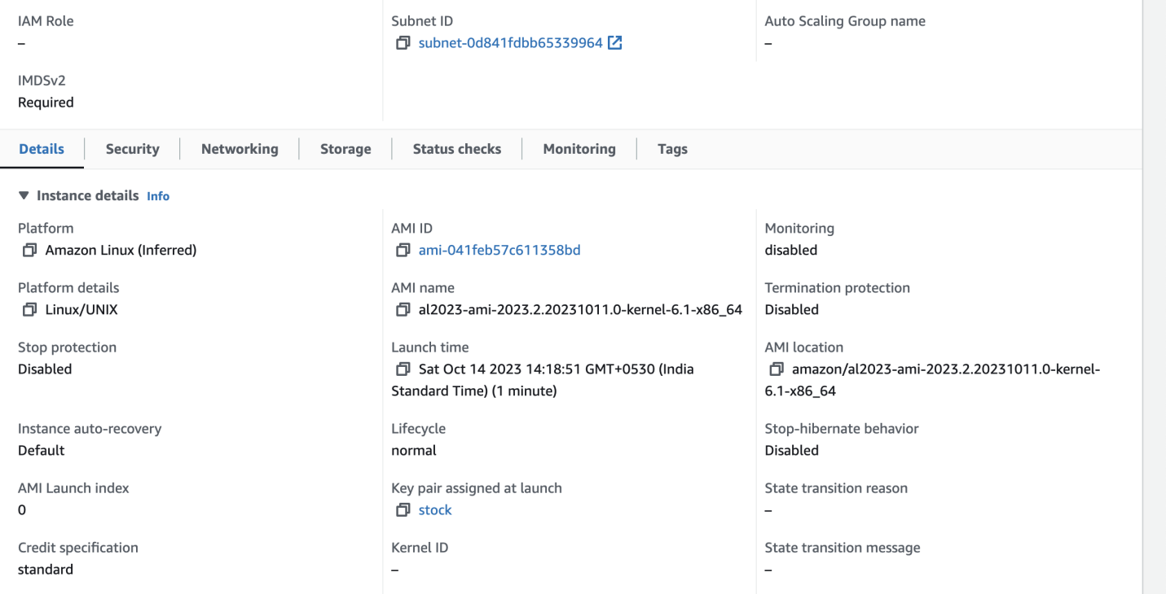

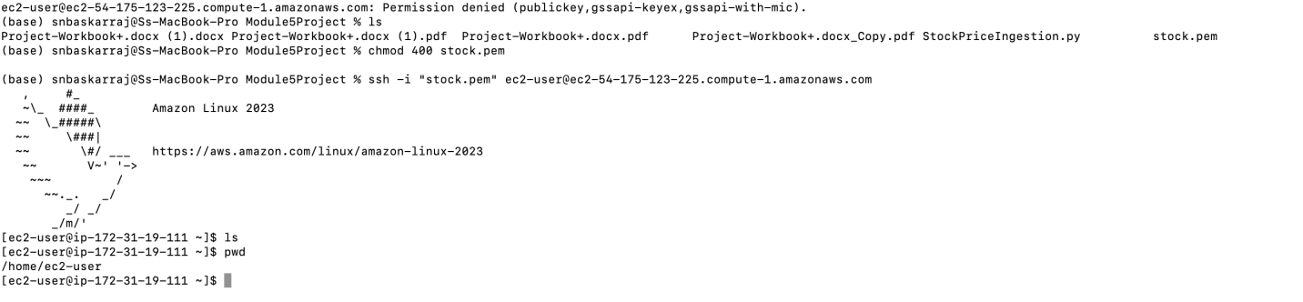



Step 2 : Run Python Script to Pull data from Public API

|  |
| --- |
| Step number a  Step name  Instructions 1) Your goal is to get stock information for the ten stocks specified  in the doc. Please take the postMarket Price.  2) Further, you should call the static info api for the stocks to get their current 52WeekHigh and 52WeekLow values.  3) Update the given python code (StockPriceIngestion.py) accordingly.  4) Print the data on the console and run the script.  Expected 1) EC2 terminal after successful execution of the edited script. It  screenshots doesn’t have to show all of the data. |

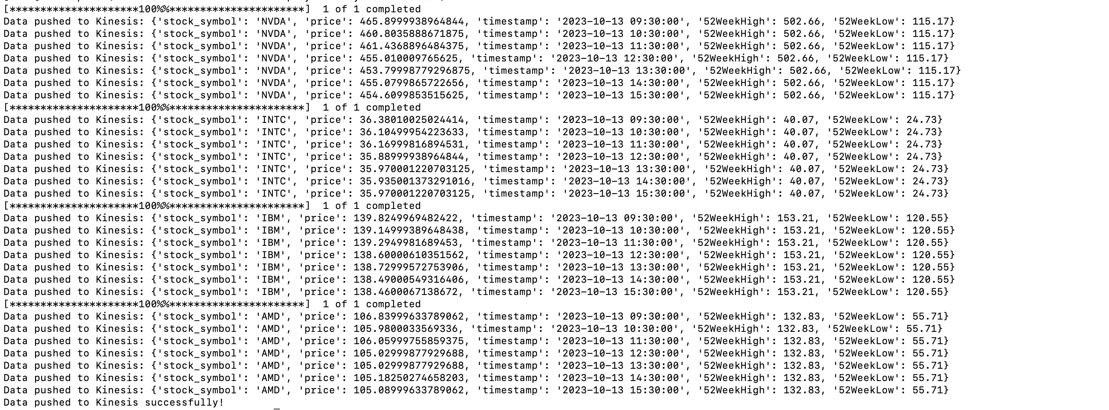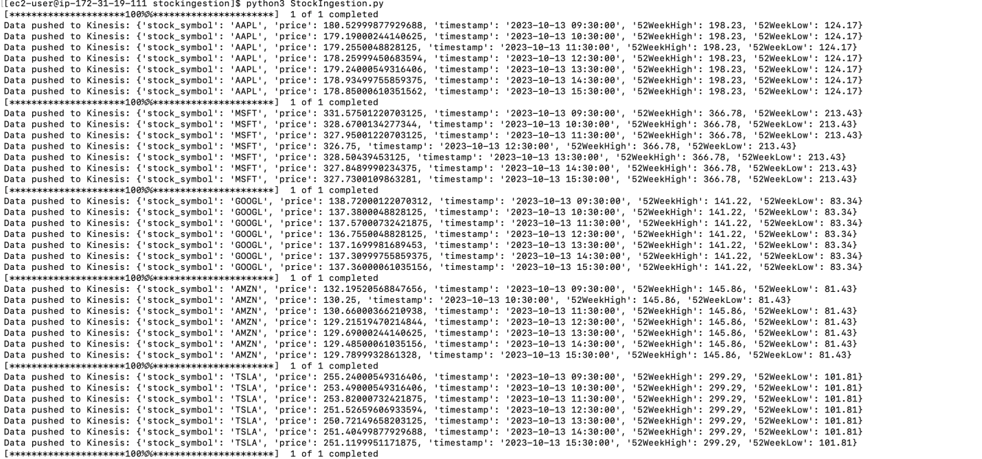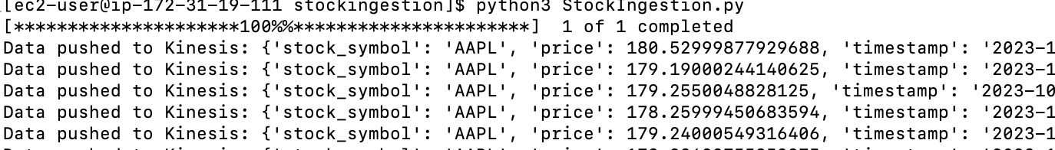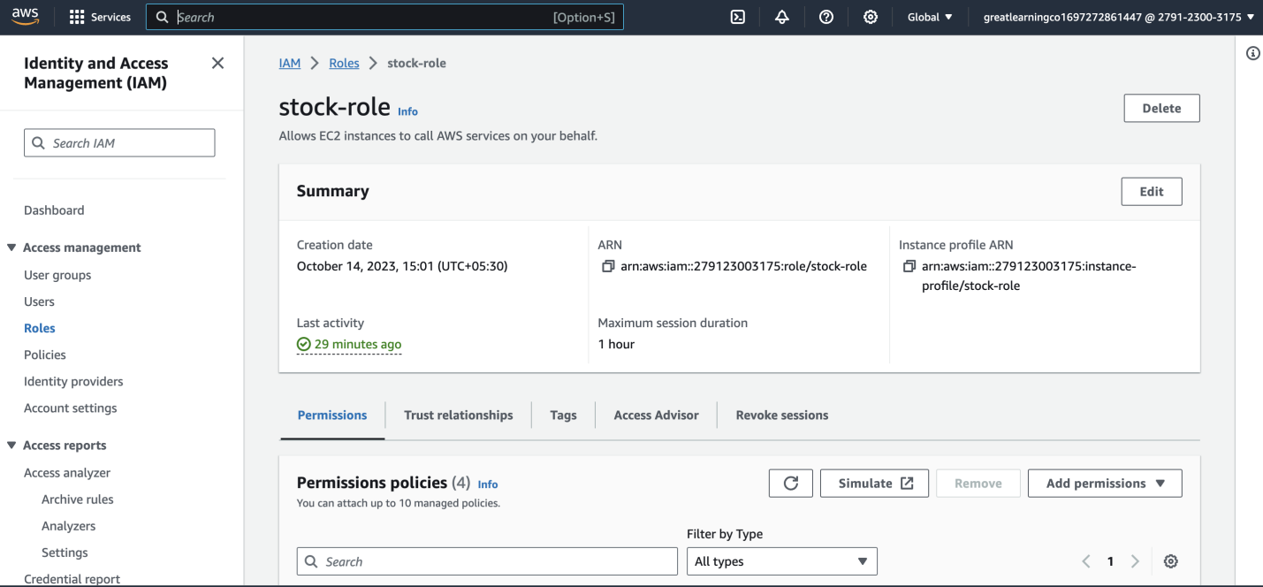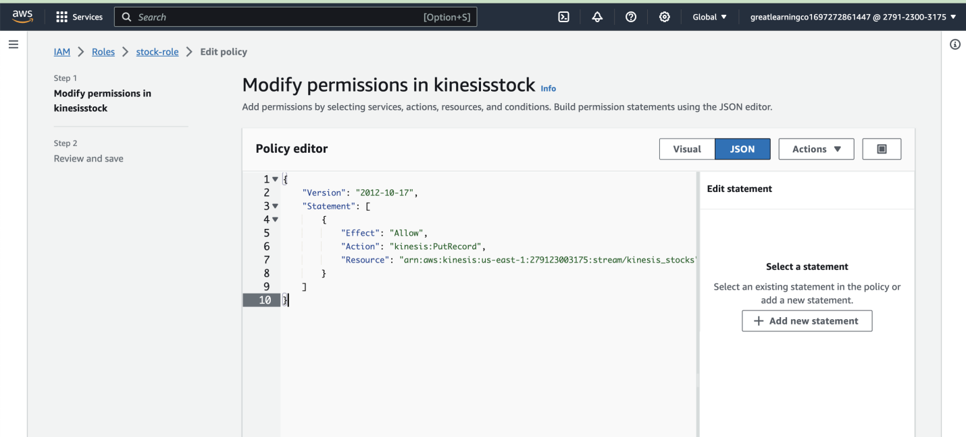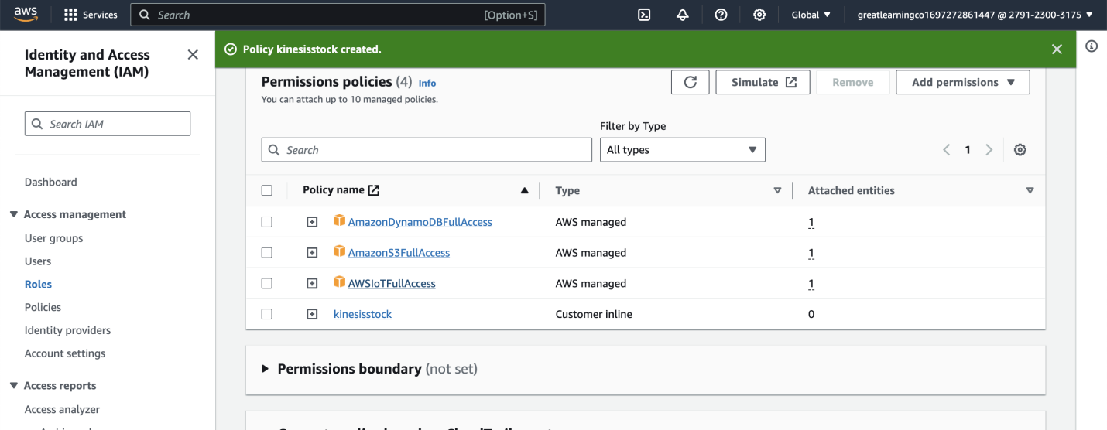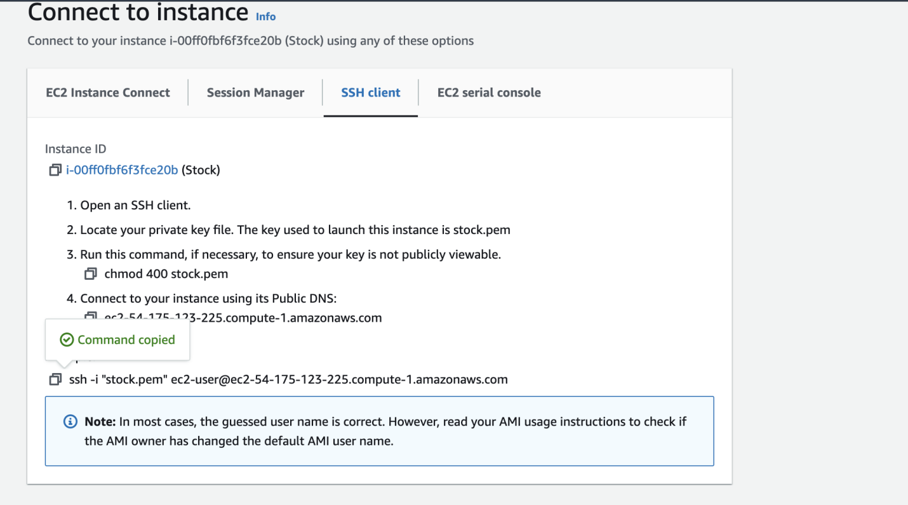

Step 3 : Use boto3 and kinesis client to Push data from EC2 to Kinesis Stream

|  |  |
| --- | --- |
| Step number Step name | a  Data in kinesis stream |

This file is meant for personal use by snbaskar@gmail.com only.

Sharing or publishing the contents in part or full is liable for legal action.



|  |  |
| --- | --- |
| Instructions  Expected  screenshots | 1) Go to the Kinesis stream services.  2) Configure the data stream to accept the data pushed by the script.  3) Create and attach appropriate policy and the IAM role to push the data to Kinesis stream from EC2. (helpful link -  <https://docs.amazonaws.cn/en_us/streams/latest/dev/tutorial-sto> ck-data-kplkcl-iam.html)  4) Edit the name of the created input kinesis stream inside the python script as required.  5) You should craft individual data records with information about the stockid, postMarket Price, 52WeekHigh and 52WeekLow values and push them individually on the Kinesis stream.  1) Screenshot of created kinesis data stream  2) Screenshot of the minimum 10 data points pushed on kinesis data stream (Screenshot of the EC2 terminal) |

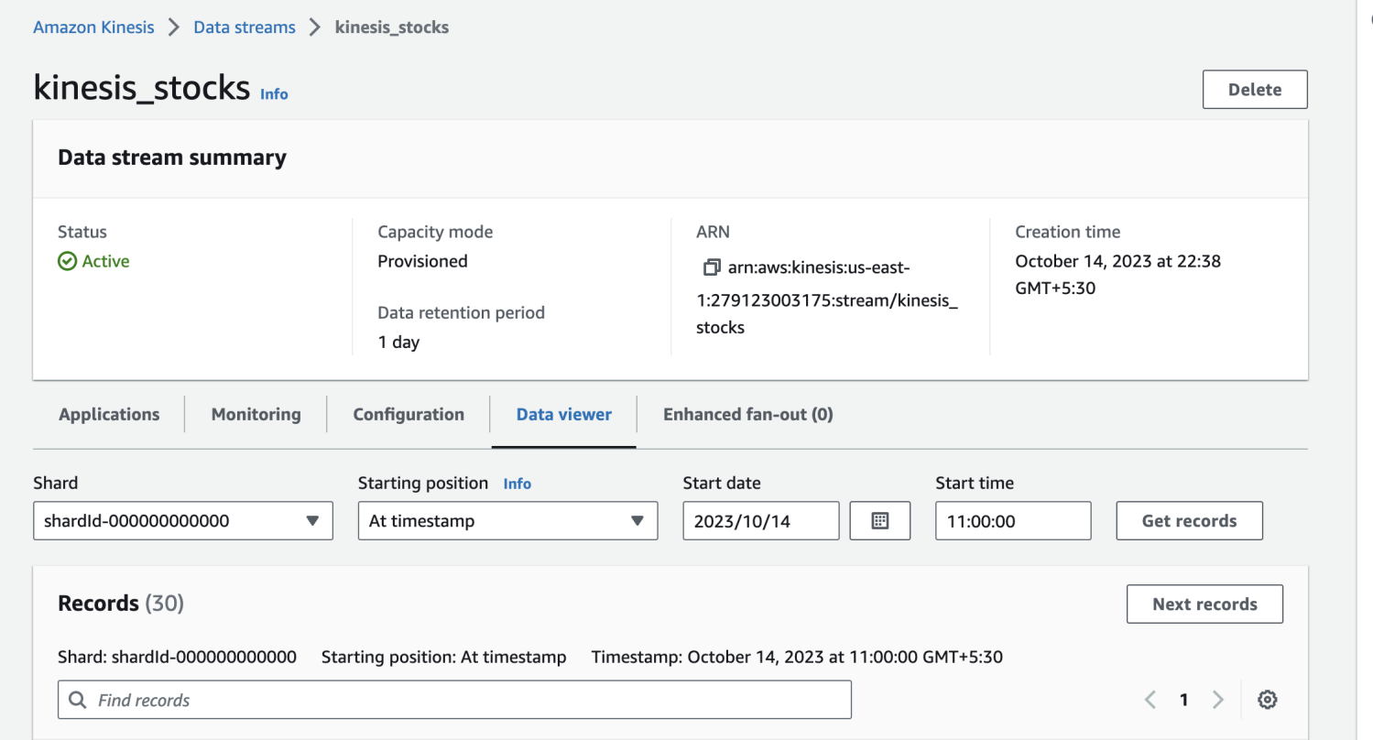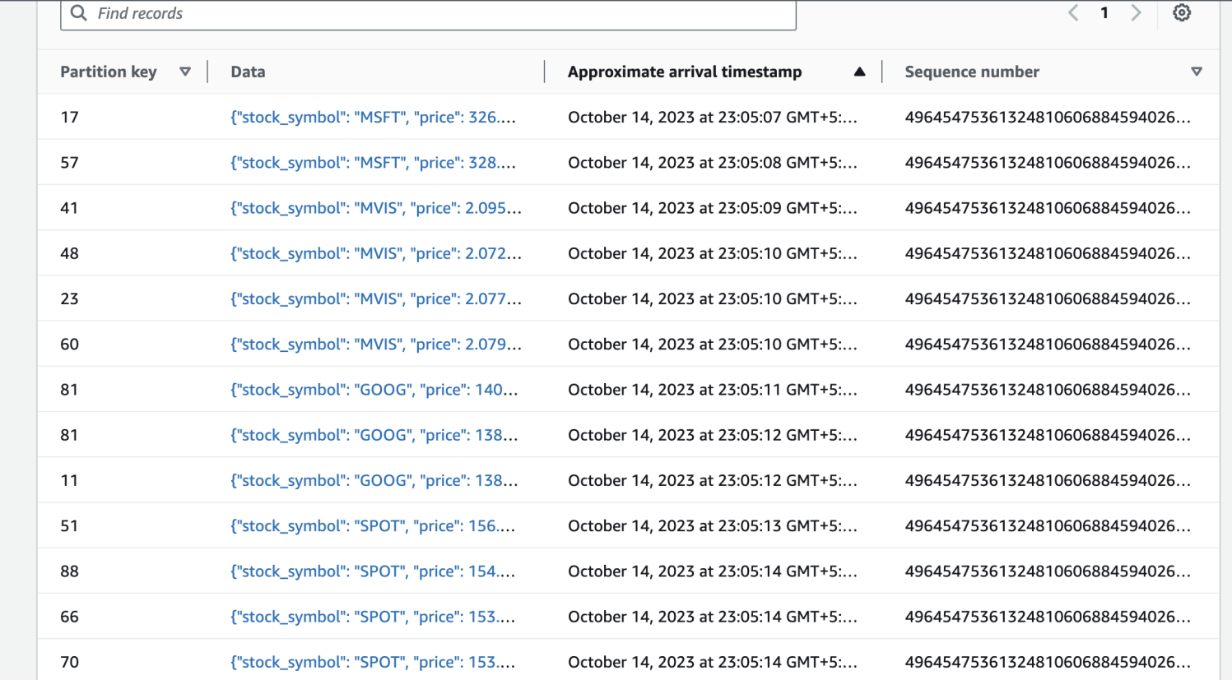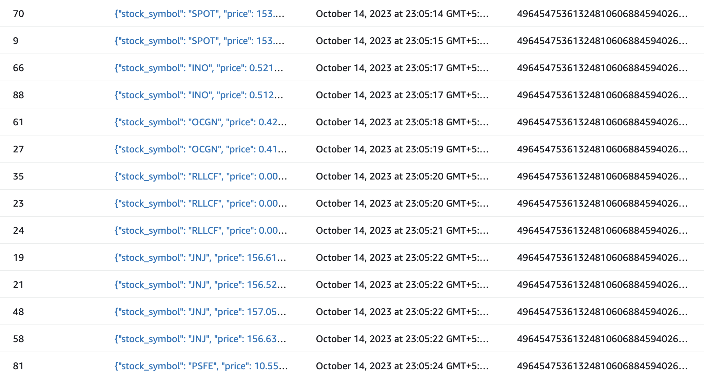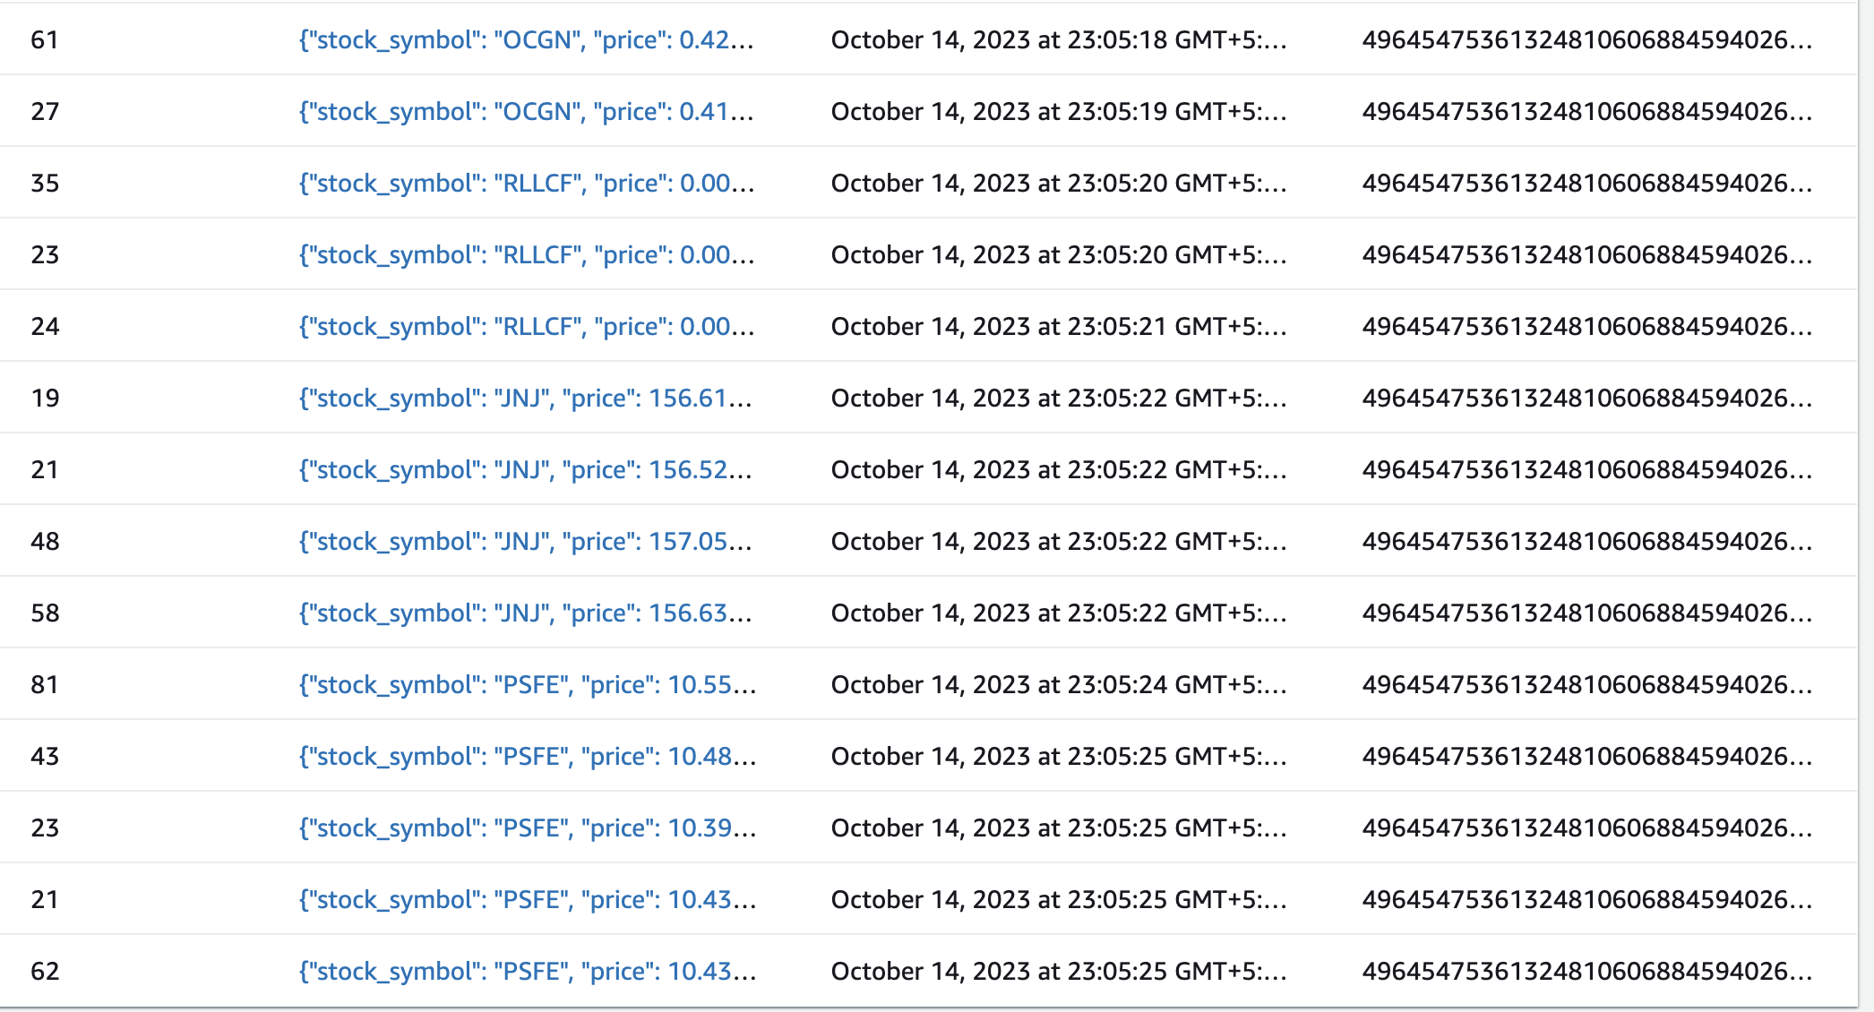

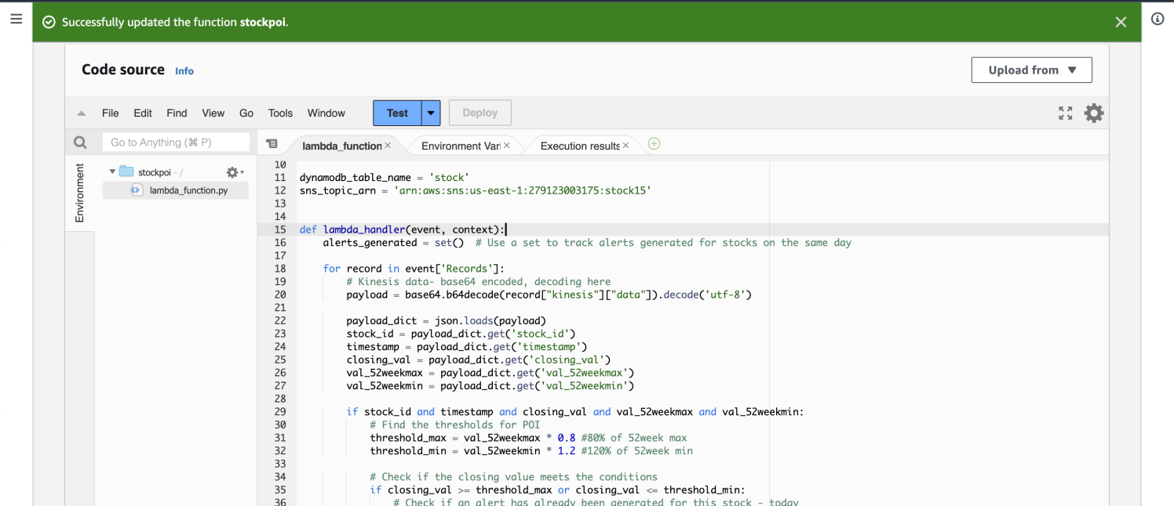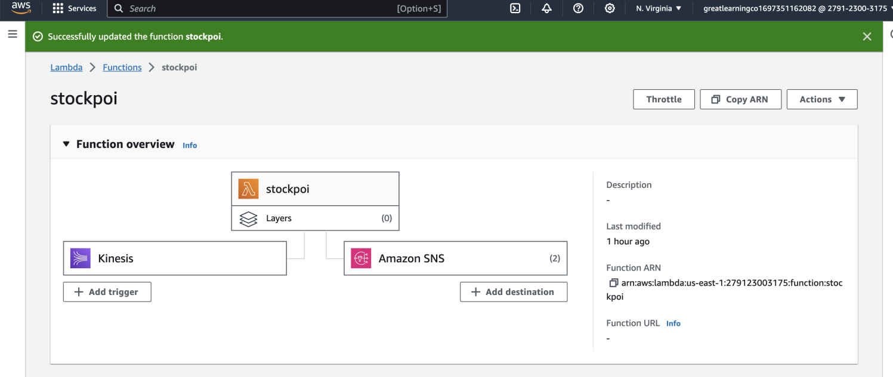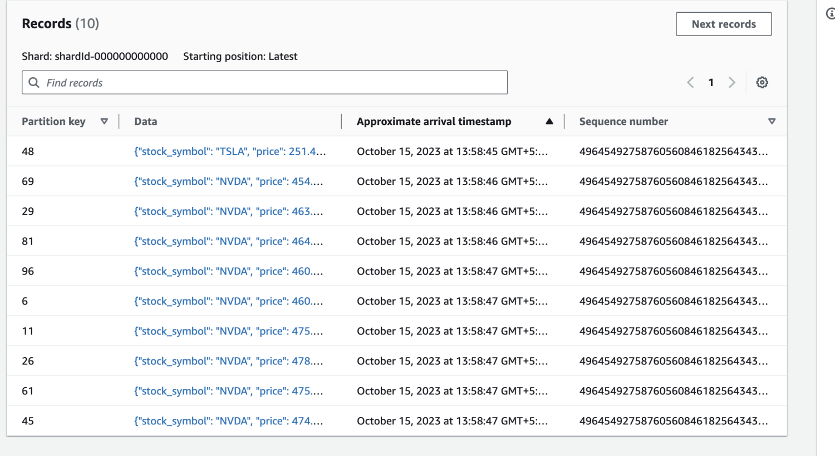

Step 4 : Write a Lambda function to get stock information and to push the Notification to SNS and add to DynamoDB

|  |  |  |
| --- | --- | --- |
| Step number Step name Instructions | a  Write the lambda function  1) Choose lambda services and create a lambda  handler. Set it up to act as a consumer to your Kinesis  data stream  (<https://docs.aws.amazon.com/lambda/latest/dg/with->  kinesis.html)  2) For each stock, get the information and push it to  SNS and dynamodb. | |
| Expected  screenshots | | 1) Created Lambda handler |

I have added the Cloud-watch logs as well which was useful in understanding the issues faced during execution over multiple iterations.

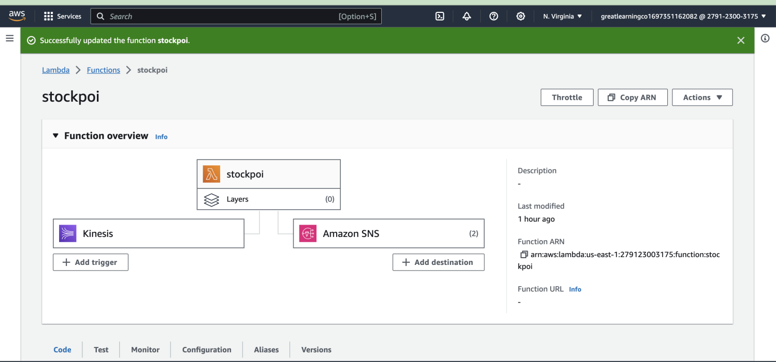

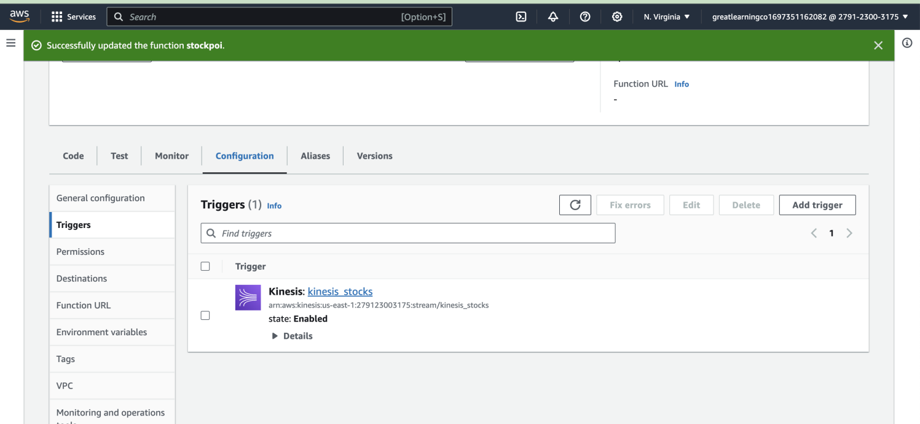

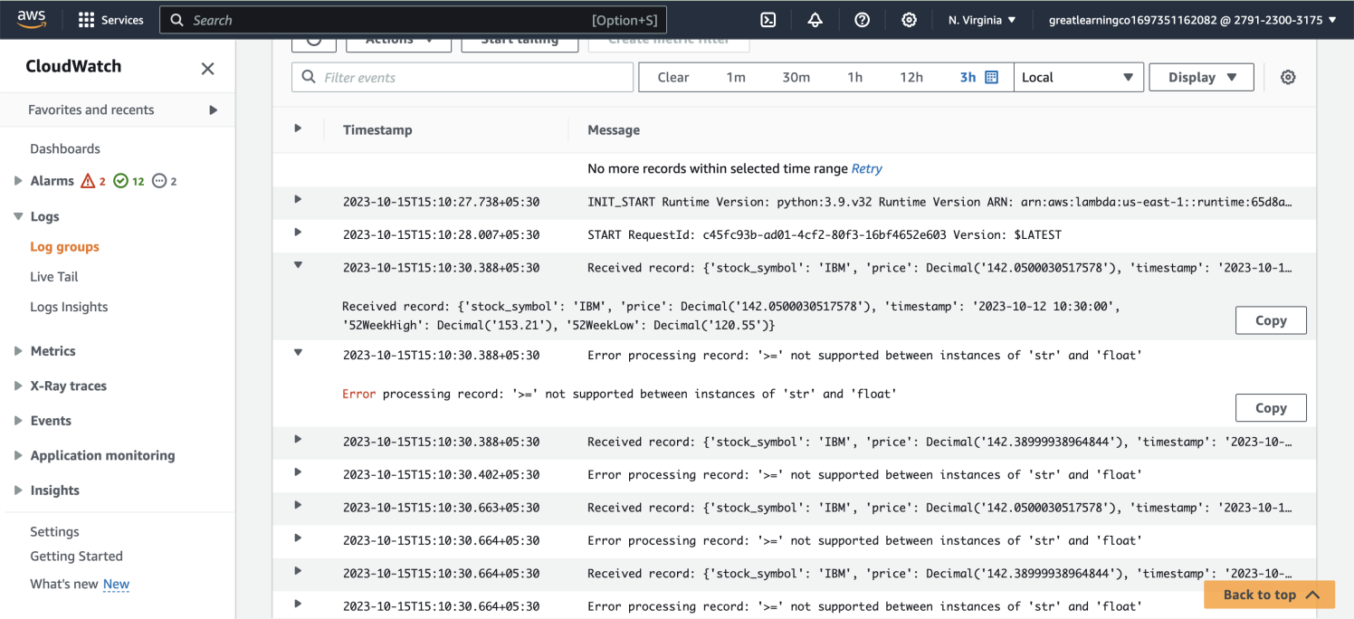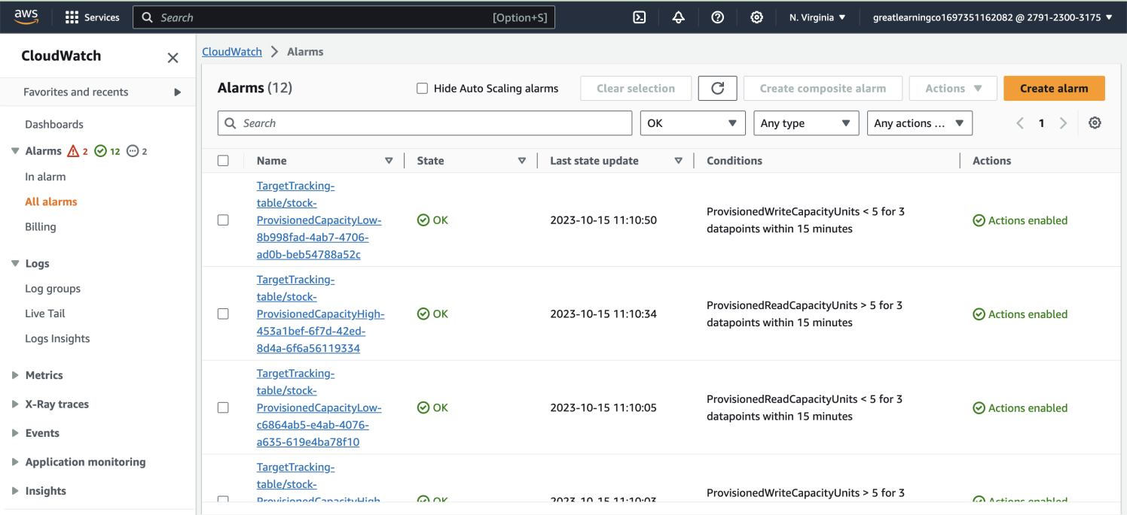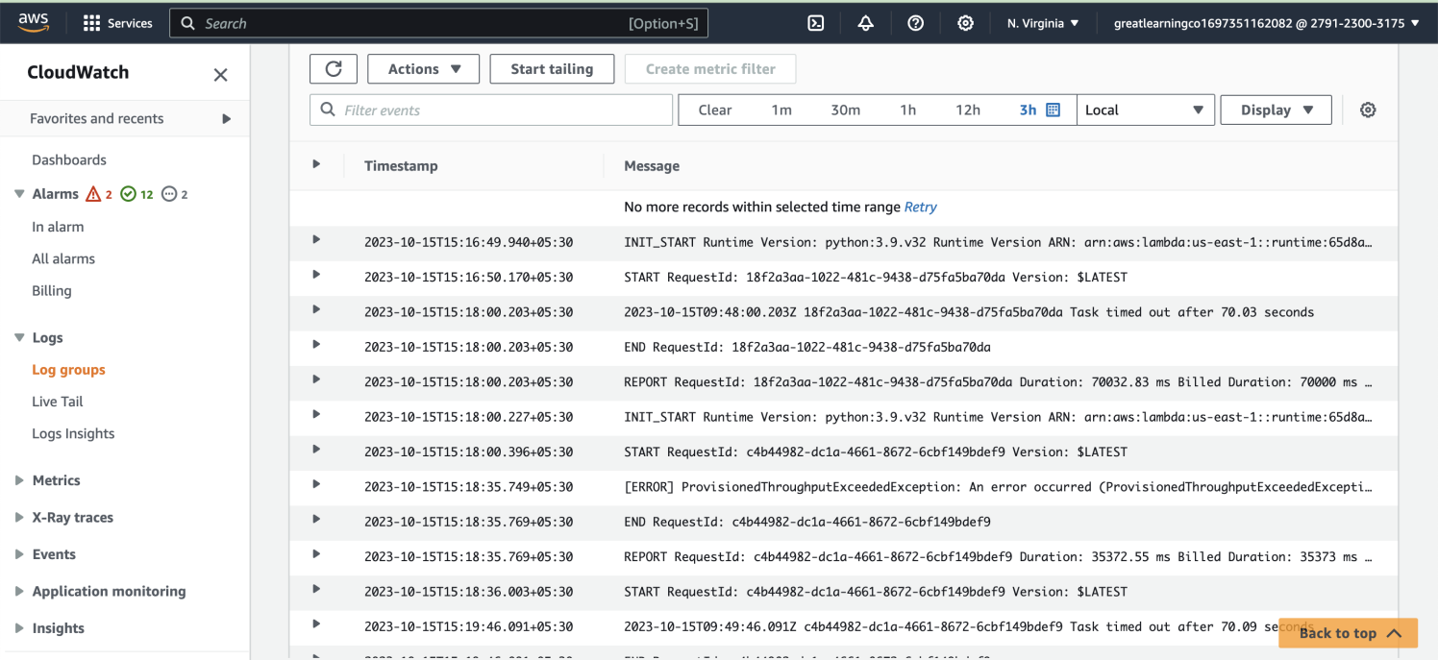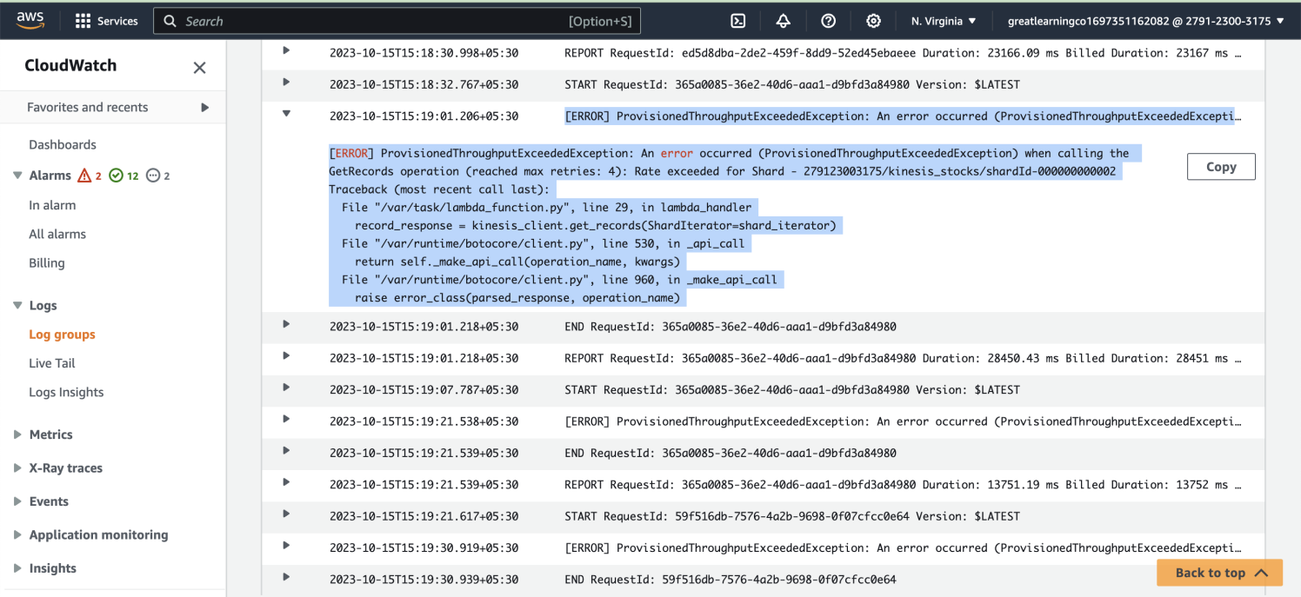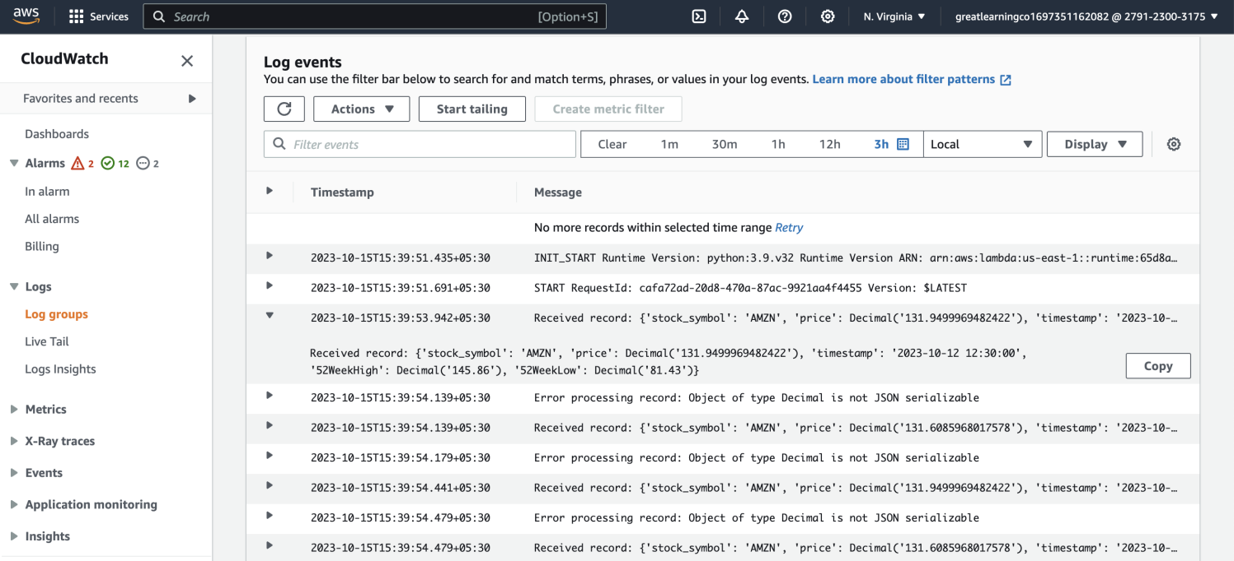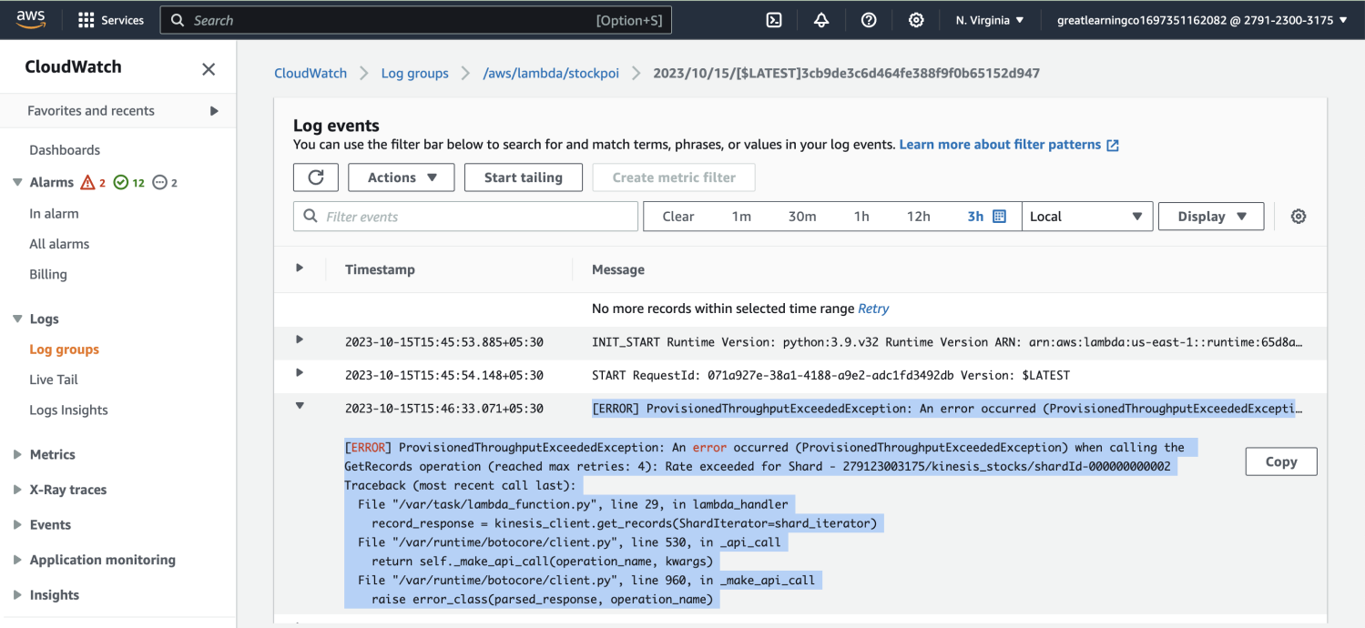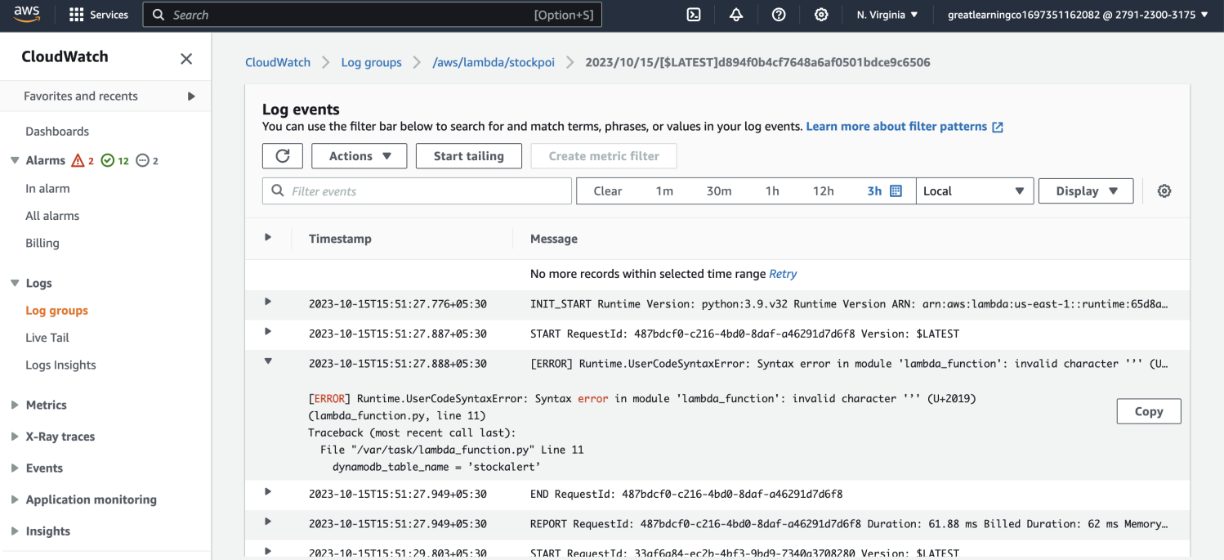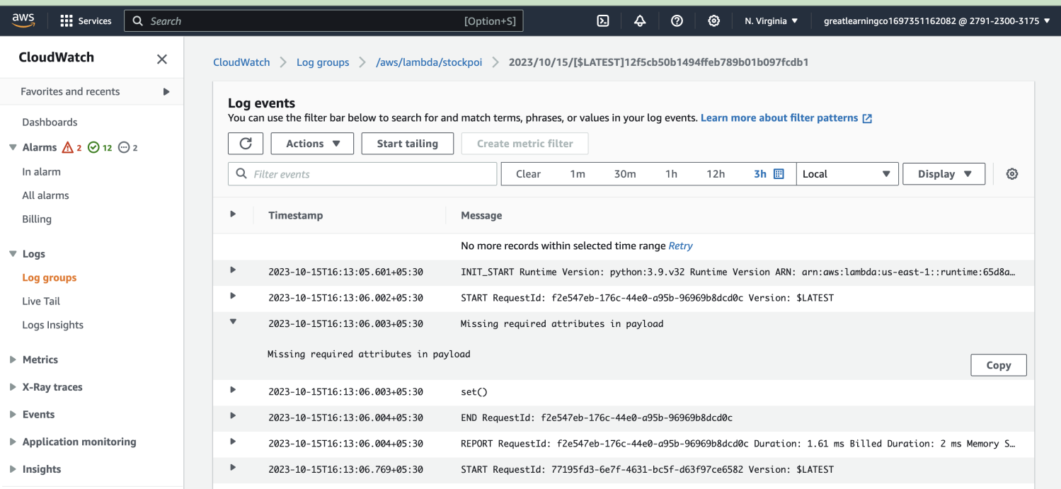

**<Insert Screenshot a(1) here>**

|  |  |
| --- | --- |
| Step number  Step name  Instructions | b  SNS topic and subscription creation  1) Goto AWS services look for SNS service  2) Create a standard topic  3) Create a subscription and subscribe to the topic using your email |
| Expected  screenshots | 1) SNS ARN for the created topic  2) Confirmation email for the created subscription  3) Point of interest data received through, once lambda handler is deployed |

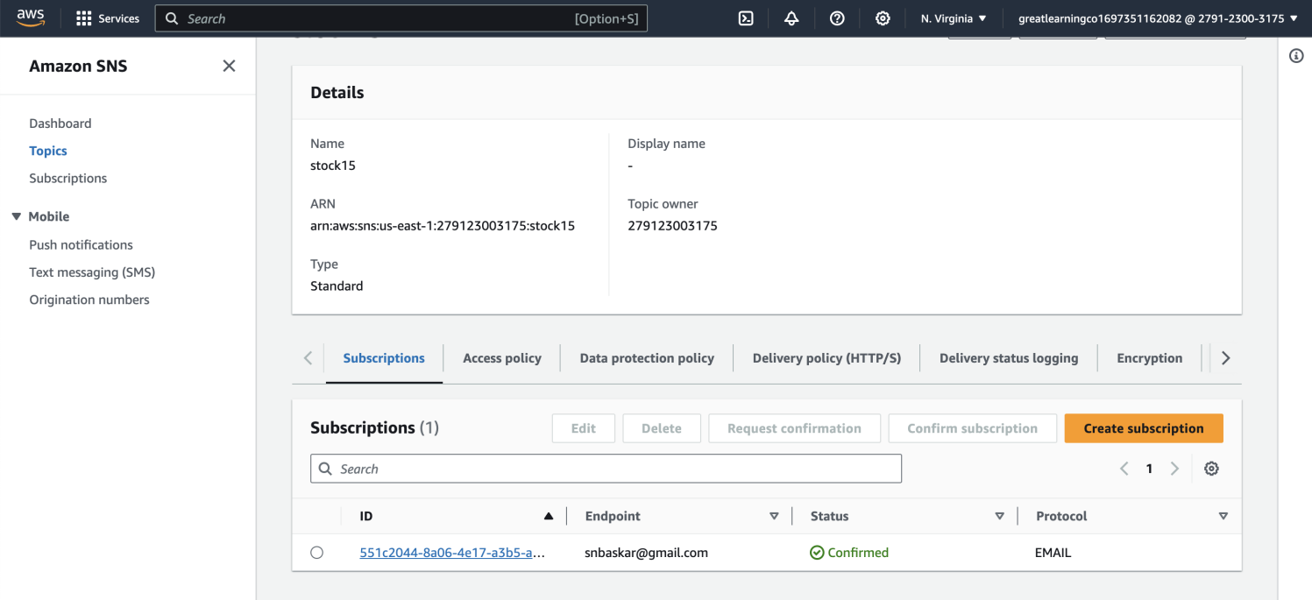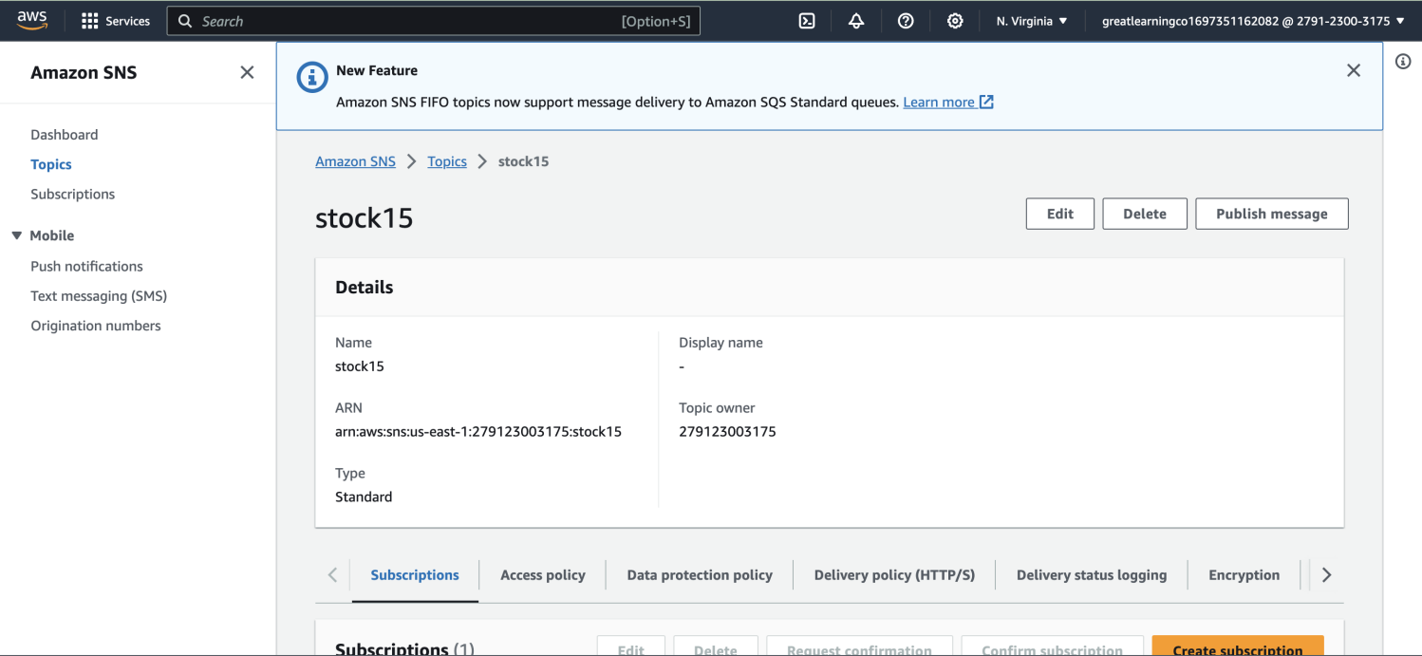

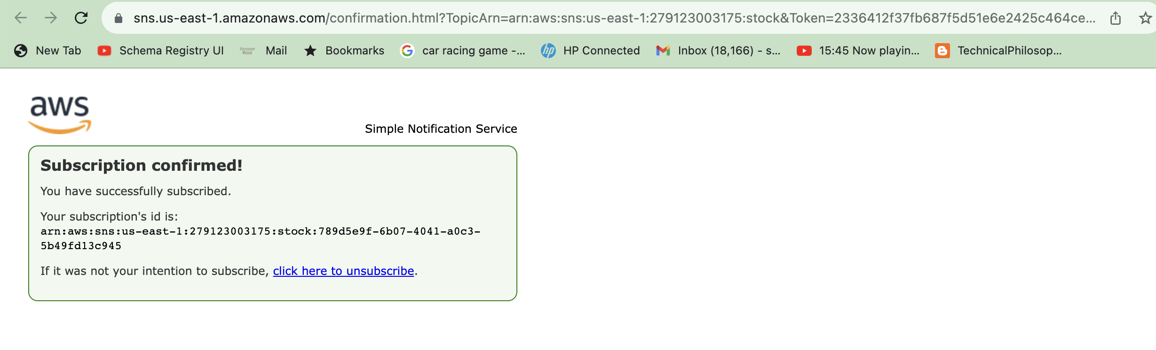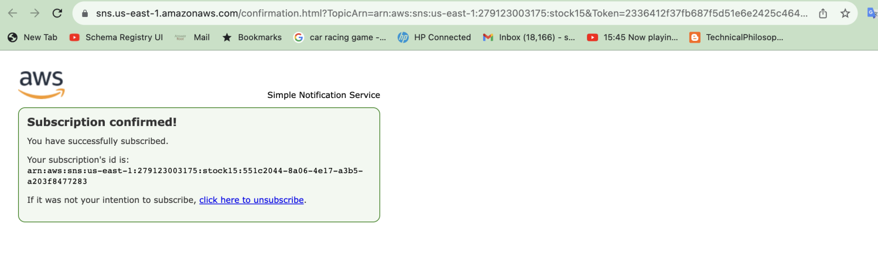

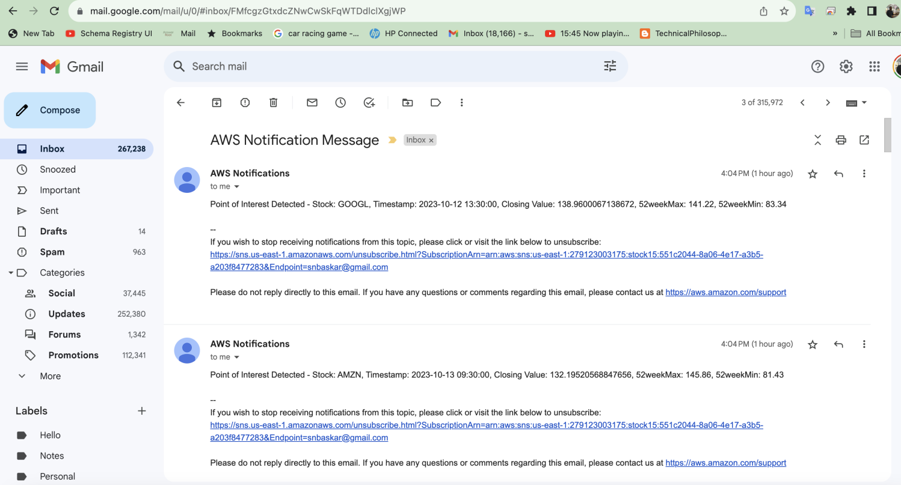

|  |  |
| --- | --- |
| Step number  Step name  Instructions | c  Dynamodb table creation  1) Goto AWS services and search for dynamodb  2) Create a table by providing the partition key and sort key |
| Expected  screenshots | 1) Empty Table  2) Table with stored data |

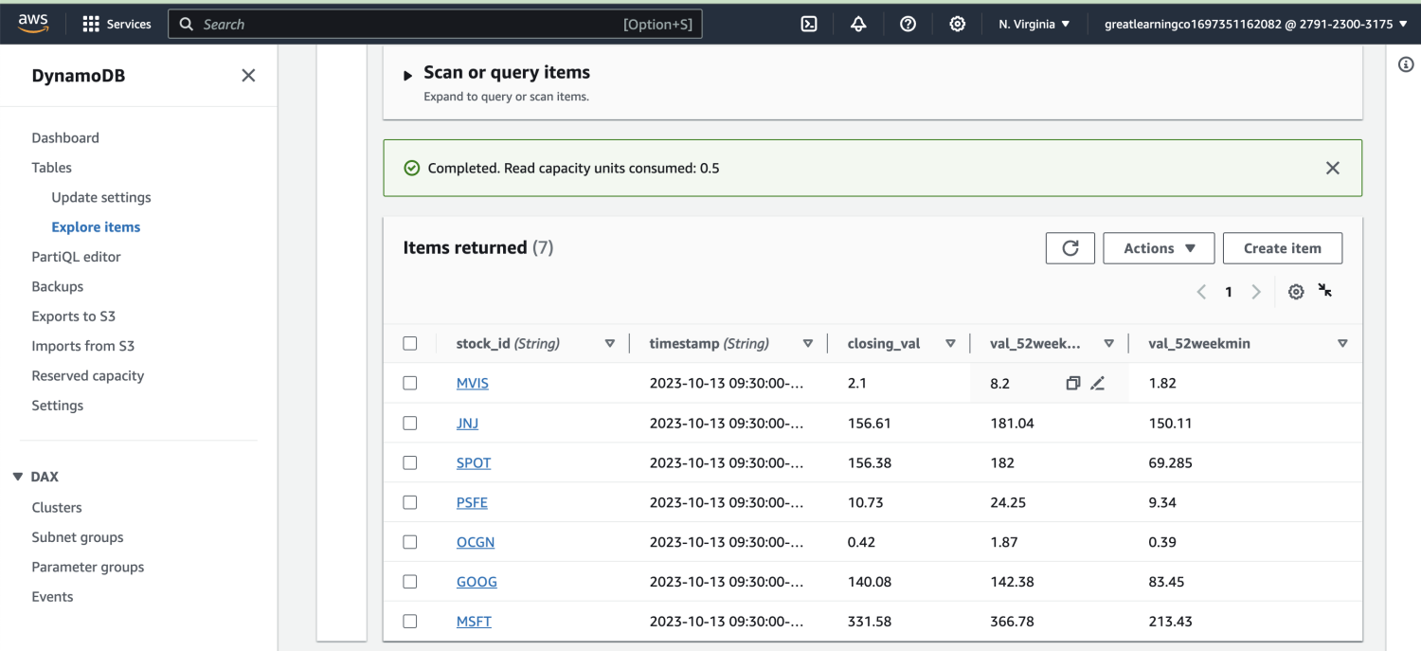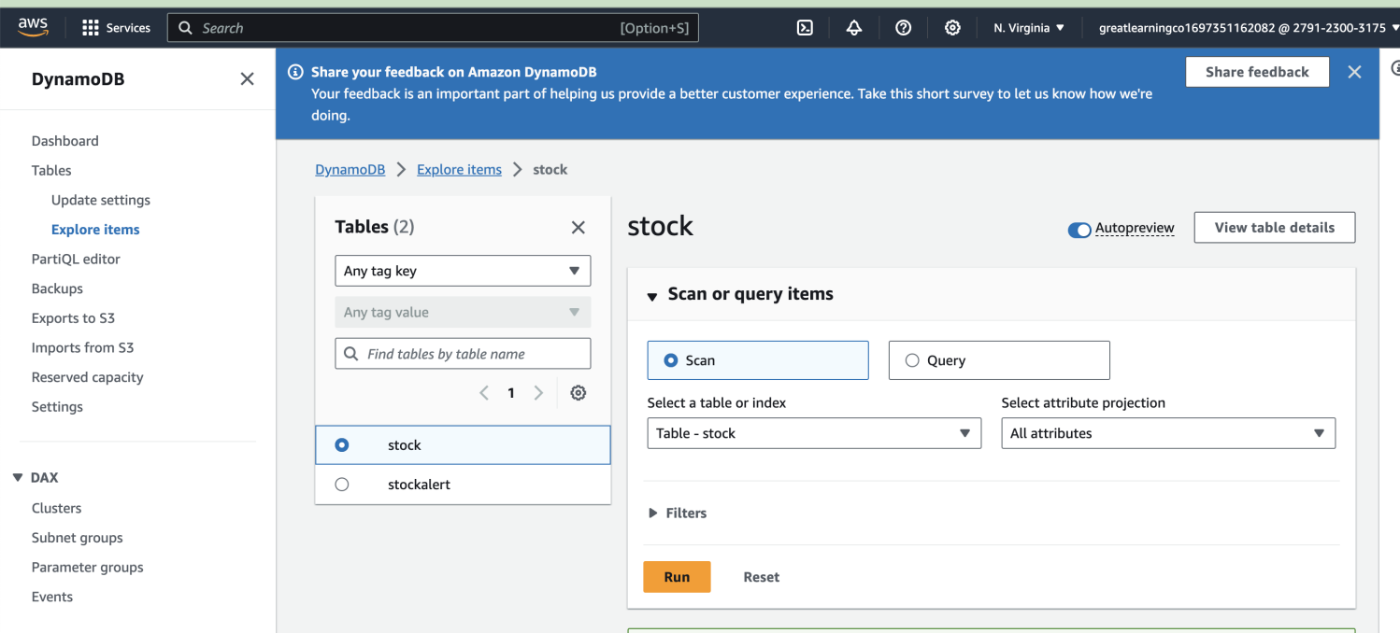

Ran Multiple iterations and Multiple times with Dynamodb and SNS notification:

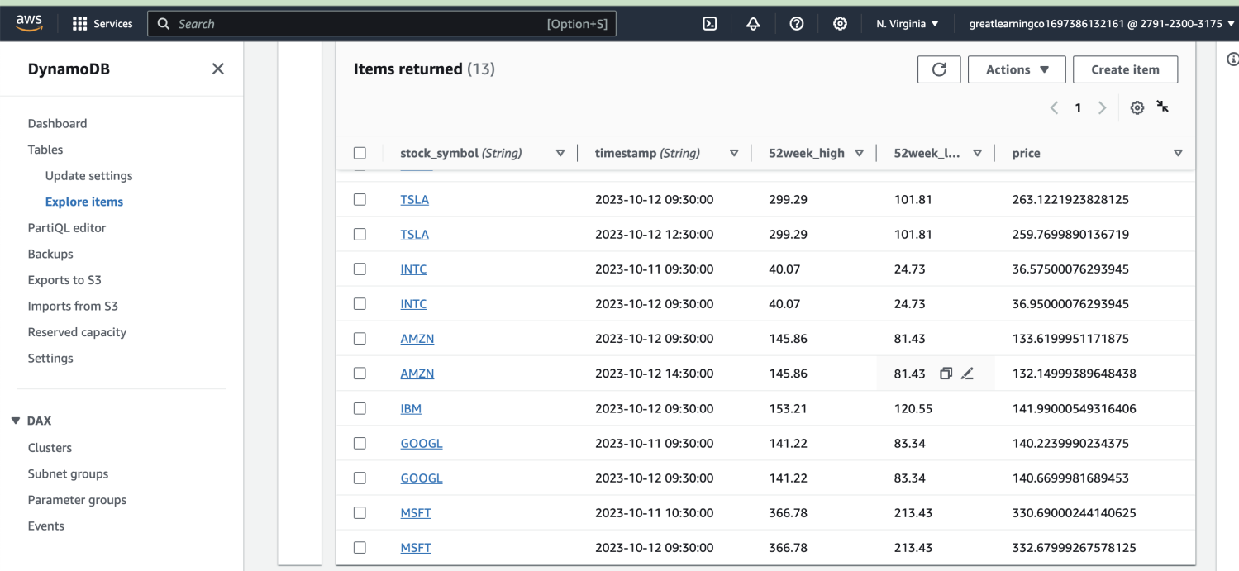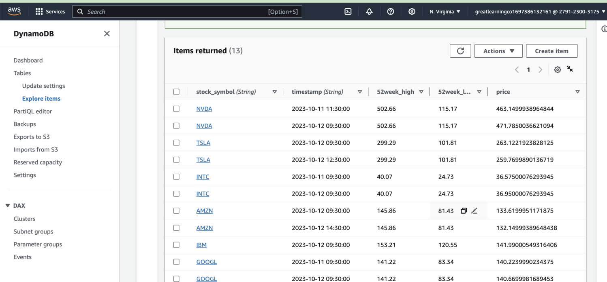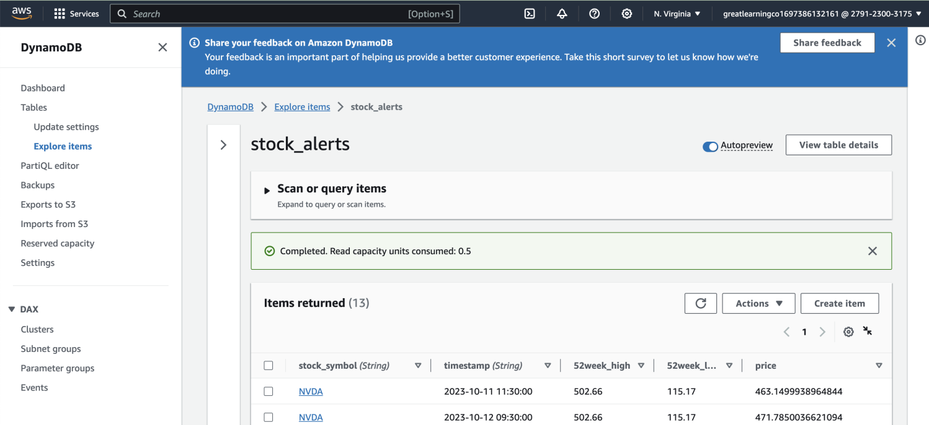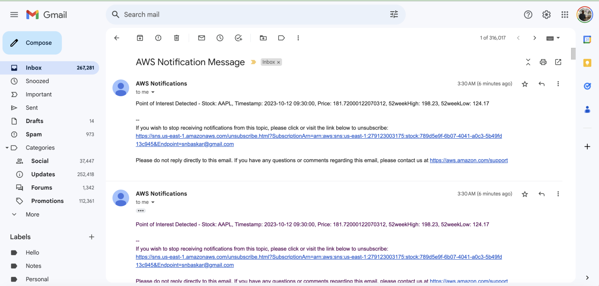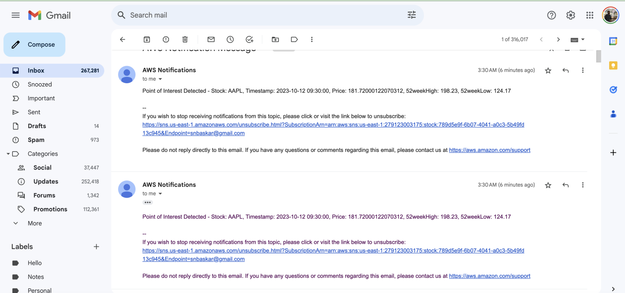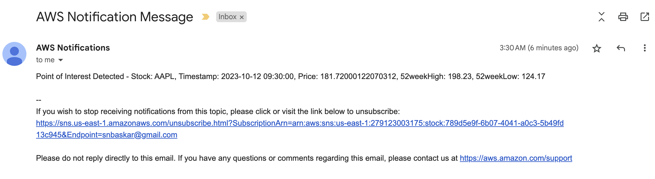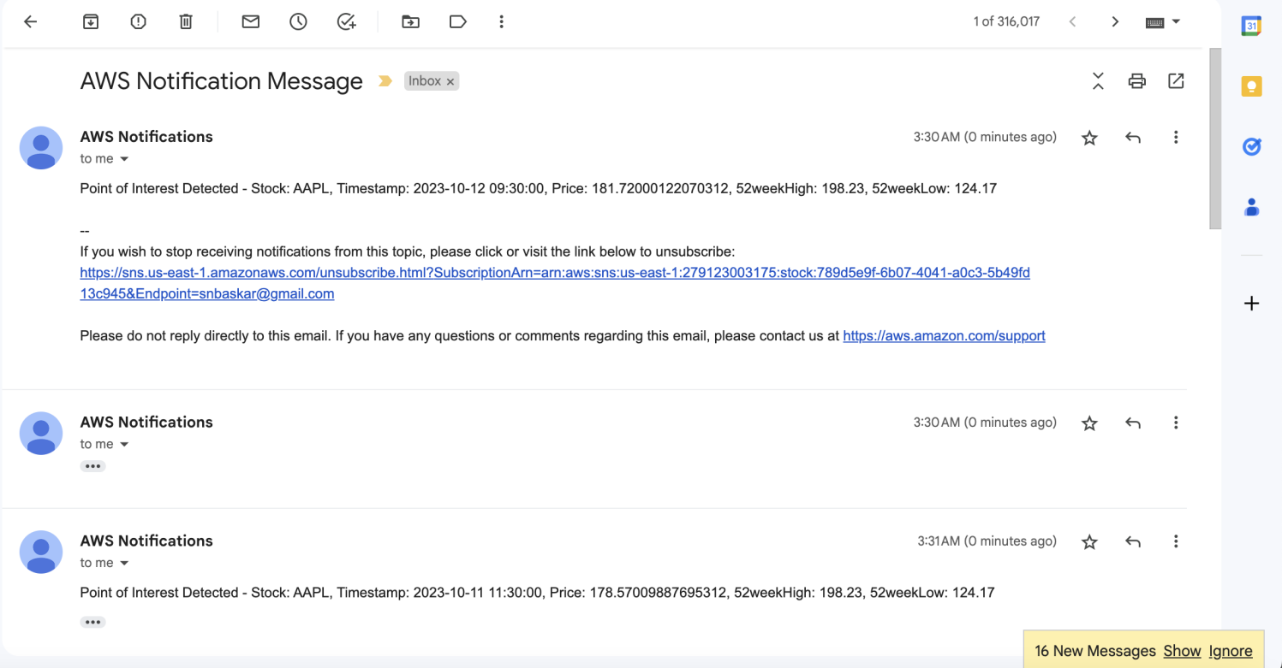

Summary of Activities and Debugging:

* **Objective**: The goal was to create an AWS Lambda function that consumes records from an AWS Kinesis stream, performs Point of Interest (POI) detection on the stock data, and sends notifications via Amazon SNS for stocks that meet certain criteria. Additionally, the Lambda function should store relevant data in Amazon DynamoDB.
* **Code Integration**: The provided code snippets were integrated into the Lambda function to handle Kinesis records, perform POI detection, and interact with DynamoDB and SNS.
* **Payload Handling**: The Lambda function was adapted to handle the payloads provided in the Kinesis records. Specifically, it extracts stock-related attributes such as stock symbol, timestamp, price, 52-week high, and 52-week low from the payload.
* **POI Detection**: The Lambda function calculates the thresholds for POI detection based on the 52-week high and low values. It checks if the price falls outside the specified thresholds and generates alerts accordingly.
* **DynamoDB Storage**: When a stock meets the POI criteria, the Lambda function stores the relevant data (stock symbol, timestamp, price, 52-week high, 52-week low) in an Amazon DynamoDB table.
* **SNS Notifications**: Alerts for stocks meeting the POI criteria are sent to an Amazon SNS topic, which can be configured to send notifications through email.
* **Error Handling and Debugging**:
  + The code initially faced a KeyError related to the 'Kinesis' key when attempting to parse Kinesis records. This was resolved by ensuring that the Lambda event parameter provided to the function contains the expected structure.
  + The payload extraction and attribute checks were enhanced to handle the specific payload structure provided in Kinesis records.
* **Testing**: The Lambda function should be tested with sample Kinesis records to ensure that it correctly processes records, performs POI detection, and interacts with DynamoDB and SNS as expected.

Overall, the Lambda function was successfully adapted to handle the specified use case and payload structure, and errors related to payload extraction were addressed. It can now be deployed and tested with real data from the Kinesis stream.

Issues Faced during this activity and Learnings:This was interesting to solve and a good learning

**Issues faced in implementing lambda handler:**

|  |  |
| --- | --- |
| [ERROR] ProvisionedThroughputExceededException: An error occurred (ProvisionedThroughputExceededException) when calling the GetRecords operation (reached max retries: 4): Rate exceeded for Shard - 279123003175/kinesis_stocks/shardId-000000000000  Traceback (most recent call last):    File "/var/task/lambda_function.py", line 28, in lambda_handler      record_response = kinesis_client.get_records(ShardIterator=record_response['NextShardIterator'])    File "/var/runtime/botocore/client.py", line 530, in _api_call      return self._make_api_call(operation_name, kwargs)    File "/var/runtime/botocore/client.py", line 960, in _make_api_call      raise error_class(parsed_response, operation_name) | [ERROR] ProvisionedThroughputExceededException: An error occurred (ProvisionedThroughputExceededException) when calling the GetRecords operation (reached max retries: 4): Rate exceeded for Shard - 279123003175/kinesis_stocks/shardId-000000000000 Traceback (most recent call last):   File "/var/task/lambda_function.py", line 28, in lambda_handler     record_response = kinesis_client.get_records(ShardIterator=record_response['NextShardIterator'])   File "/var/runtime/botocore/client.py", line 530, in _api_call     return self._make_api_call(operation_name, kwargs)   File "/var/runtime/botocore/client.py", line 960, in _make_api_call     raise error_class(parsed_response, operation_name) |

|  |  |
| --- | --- |
| [ERROR] Runtime.UserCodeSyntaxError: Syntax error in module 'lambda_function': unexpected indent (lambda_function.py, line 40)  Traceback (most recent call last):    File "/var/task/lambda_function.py" Line 40                      for item in event['Records']: | [ERROR] Runtime.UserCodeSyntaxError: Syntax error in module 'lambda_function': unexpected indent (lambda_function.py, line 40) Traceback (most recent call last):   File "/var/task/lambda_function.py" Line 40                     for item in event['Records']: |

|  |  |
| --- | --- |
| [ERROR] ClientError: An error occurred (AccessDeniedException) when calling the PutItem operation: User: arn:aws:sts::279123003175:assumed-role/stockpoi-role-16skr3gn/stockpoi is not authorized to perform: dynamodb:PutItem on resource: arn:aws:dynamodb:us-east-1:279123003175:table/stock because no identity-based policy allows the dynamodb:PutItem action  Traceback (most recent call last):    File "/var/task/lambda_function.py", line 47, in lambda_handler      dynamodb_client.put_item(    File "/var/runtime/botocore/client.py", line 530, in _api_call      return self._make_api_call(operation_name, kwargs)    File "/var/runtime/botocore/client.py", line 960, in _make_api_call      raise error_class(parsed_response, operation_name) | [ERROR] ClientError: An error occurred (AccessDeniedException) when calling the PutItem operation: User: arn:aws:sts::279123003175:assumed-role/stockpoi-role-16skr3gn/stockpoi is not authorized to perform: dynamodb:PutItem on resource: arn:aws:dynamodb:us-east-1:279123003175:table/stock because no identity-based policy allows the dynamodb:PutItem action Traceback (most recent call last):   File "/var/task/lambda_function.py", line 47, in lambda_handler     dynamodb_client.put_item(   File "/var/runtime/botocore/client.py", line 530, in _api_call     return self._make_api_call(operation_name, kwargs)   File "/var/runtime/botocore/client.py", line 960, in _make_api_call     raise error_class(parsed_response, operation_name) |

|  |  |
| --- | --- |
| [ERROR] AccessDeniedException: An error occurred (AccessDeniedException) when calling the DescribeStream operation: User: arn:aws:sts::279123003175:assumed-role/stockpoi-role-16skr3gn/stockpoi is not authorized to perform: kinesis:DescribeStream on resource: arn:aws:kinesis:us-east-1:279123003175:stream/kinesis_stocks because no identity-based policy allows the kinesis:DescribeStream action  Traceback (most recent call last):    File "/var/task/lambda_function.py", line 19, in lambda_handler      response = kinesis_client.describe_stream(StreamName=my_stream_name)    File "/var/runtime/botocore/client.py", line 530, in _api_call      return self._make_api_call(operation_name, kwargs)    File "/var/runtime/botocore/client.py", line 960, in _make_api_call      raise error_class(parsed_response, operation_name) | [ERROR] AccessDeniedException: An error occurred (AccessDeniedException) when calling the DescribeStream operation: User: arn:aws:sts::279123003175:assumed-role/stockpoi-role-16skr3gn/stockpoi is not authorized to perform: kinesis:DescribeStream on resource: arn:aws:kinesis:us-east-1:279123003175:stream/kinesis_stocks because no identity-based policy allows the kinesis:DescribeStream action Traceback (most recent call last):   File "/var/task/lambda_function.py", line 19, in lambda_handler     response = kinesis_client.describe_stream(StreamName=my_stream_name)   File "/var/runtime/botocore/client.py", line 530, in _api_call     return self._make_api_call(operation_name, kwargs)   File "/var/runtime/botocore/client.py", line 960, in _make_api_call     raise error_class(parsed_response, operation_name) |

|  |  |
| --- | --- |
| [ERROR] ProvisionedThroughputExceededException: An error occurred (ProvisionedThroughputExceededException) when calling the GetRecords operation (reached max retries: 4): Rate exceeded for Shard - 279123003175/kinesis_stocks/shardId-000000000000  Traceback (most recent call last):    File "/var/task/lambda_function.py", line 28, in lambda_handler      record_response = kinesis_client.get_records(ShardIterator=record_response['NextShardIterator'])    File "/var/runtime/botocore/client.py", line 530, in _api_call      return self._make_api_call(operation_name, kwargs)    File "/var/runtime/botocore/client.py", line 960, in _make_api_call      raise error_class(parsed_response, operation_name) | [ERROR] ProvisionedThroughputExceededException: An error occurred (ProvisionedThroughputExceededException) when calling the GetRecords operation (reached max retries: 4): Rate exceeded for Shard - 279123003175/kinesis_stocks/shardId-000000000000 Traceback (most recent call last):   File "/var/task/lambda_function.py", line 28, in lambda_handler     record_response = kinesis_client.get_records(ShardIterator=record_response['NextShardIterator'])   File "/var/runtime/botocore/client.py", line 530, in _api_call     return self._make_api_call(operation_name, kwargs)   File "/var/runtime/botocore/client.py", line 960, in _make_api_call     raise error_class(parsed_response, operation_name) |

summary of the errors encountered while implementing the Lambda handler, along with explanations for each error:

* **ProvisionedThroughputExceededException**:
  + **Error**: This error occurred when calling the GetRecords operation, indicating that the rate limit for shard access was exceeded.
  + **Explanation**: Kinesis stream shards have throughput limits, and if you exceed these limits, you'll encounter this error.
  + **Resolution**: To resolve this issue, you can either increase the provisioned throughput for the stream or reduce the rate at which you're trying to read records from the stream.
* **Runtime.UserCodeSyntaxError**:
  + **Error**: This error indicates a syntax error in your Lambda function's code.
  + **Explanation**: There was a problem with the indentation of your code, likely caused by a formatting issue.
  + **Resolution**: Check the code for indentation errors and ensure that all code blocks are properly aligned.
* **ClientError: AccessDeniedException**:
  + **Error**: This error occurred when calling the PutItem operation for DynamoDB and the DescribeStream operation for Kinesis. It indicates that the execution role of the Lambda function doesn't have the necessary permissions.
  + **Explanation**: The Lambda function's execution role should have appropriate policies attached to allow the required actions on DynamoDB and Kinesis resources.
  + **Resolution**: Update the execution role's policies to grant permissions for dynamodb:PutItem and kinesis:DescribeStream actions on the respective resources.
* **ProvisionedThroughputExceededException (Repeated)**:
  + **Error**: This error occurred again when calling the GetRecords operation, indicating that the rate limit for shard access was exceeded.
  + **Explanation**: This error can happen if the rate of reading records from the Kinesis shard is too high.
  + **Resolution**: As mentioned earlier, adjust the rate at which you're reading records from the Kinesis stream or consider increasing the shard's provisioned throughput if needed.

These errors mostly relate to issues with permissions, syntax, and throughput limits. To resolve them, ensure that your Lambda function has the correct permissions, fix any syntax errors, and consider adjusting the rate at which you access the Kinesis stream shards. Additionally, monitor and manage your AWS resources to avoid exceeding throughput limits.

This file is meant for personal use by snbaskar@gmail.com only.

Sharing or publishing the contents in part or full is liable for legal action.



This file is meant for personal use by snbaskar@gmail.com only.

Sharing or publishing the contents in part or full is liable for legal action.



This file is meant for personal use by snbaskar@gmail.com only.

Sharing or publishing the contents in part or full is liable for legal action.